EXPERIMENT 4
4.1PROGRAMS
4.1.1//Set Operation
ALGORITHM:
Step 1: Start
Step 2: Read elements of Set A
Step 3: Read elements of Set B
Step 4: Compute Union of A and B
Union = A ∪ B
Step 5: Compute Intersection of A and B
Intersection = A ∩ B
Step 6: Compute Difference of A and B
Difference = A − B
Step 7: Display Union
Step 8: Display Intersection
Step 9: Display Difference
Step 10: Stop

FLOWCHART:
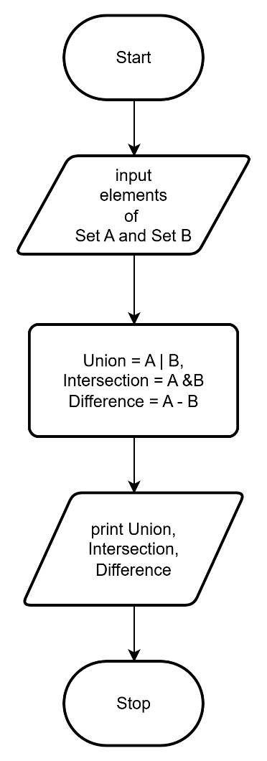
CODETANTRA:

